**Emre Çamlıca, 150210071**

**1)**

The value to be loaded into the SysTick Reload Value Register can be calculated using the formula:  
Systick Interrupt Period = (1 + Systick Load) / (CPU Frequency)

* Systick Load = (Systick Interrupt Period) x (CPU Frequency) -1

For my values: Systick Load = (177 ms)x(64MHz) - 1 = (177 x 10-3 s) x (64 x 106 (1/s)) - 1 = 11327999

Therefore, the value should be 1132799

**3)**

After obtaining the running time array for Bubblesort, I created a scatter plot using the array values in Python. The following figure illustrates the relationship between the array size and the running time of Bubblesort.

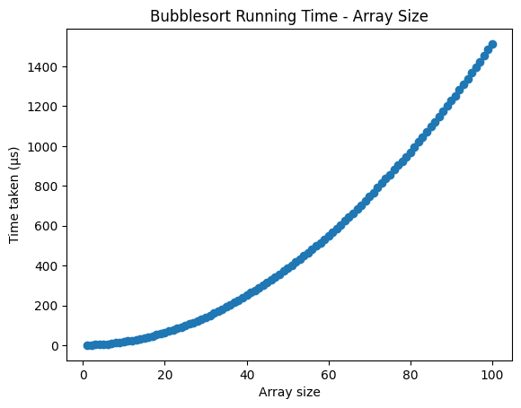

It can be observed from the figure that there is quadratic relationship between the array size and the running time of the Bubblesort. This is the expected behaviour for the Bubblesort as it checks every number in the inner loop, for every number in the outer loop, resulting in a time complexity of O(n2).